Please keep this document confidential

General concept
- Gas production pushes the liquid in a U-tube to touch a liquid level sensor
- The liquid level sensor signals Arduino to trigger a solenoid valve to open to the atmosphere, which resets the liquid level
- Each liquid level change and reset is a consistent known volume. Counting the times that liquid level is triggered gives the gas production volume

Step 1:
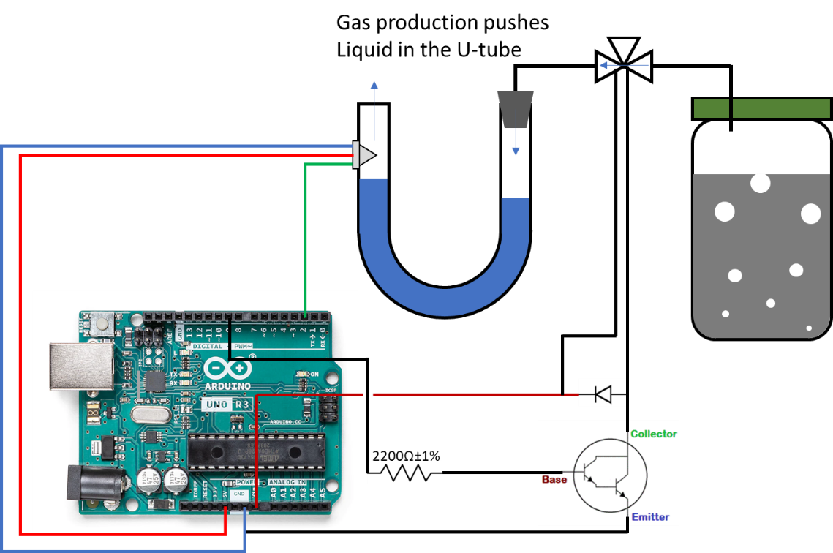
Step 2:
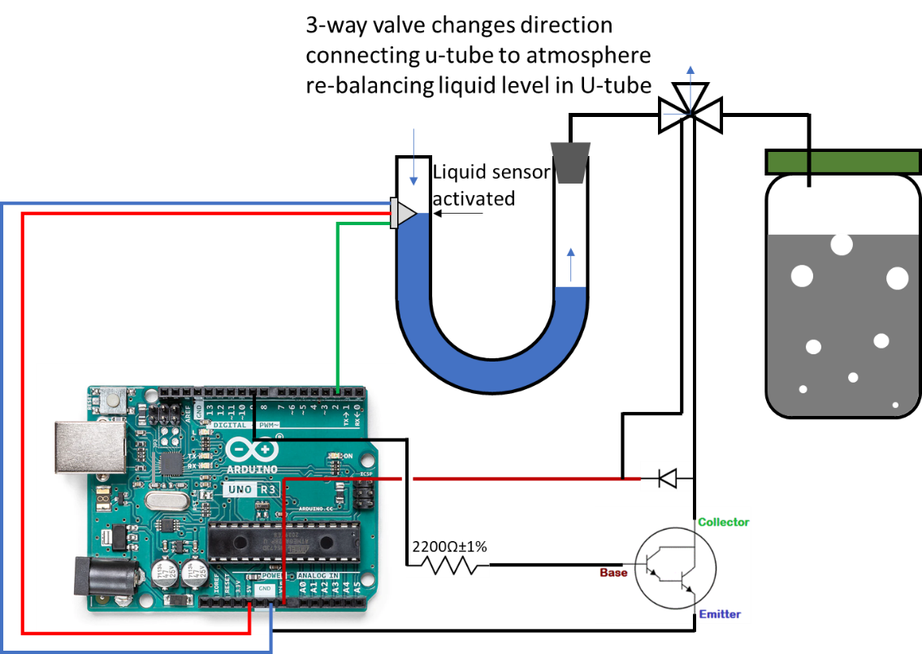
Step 3:
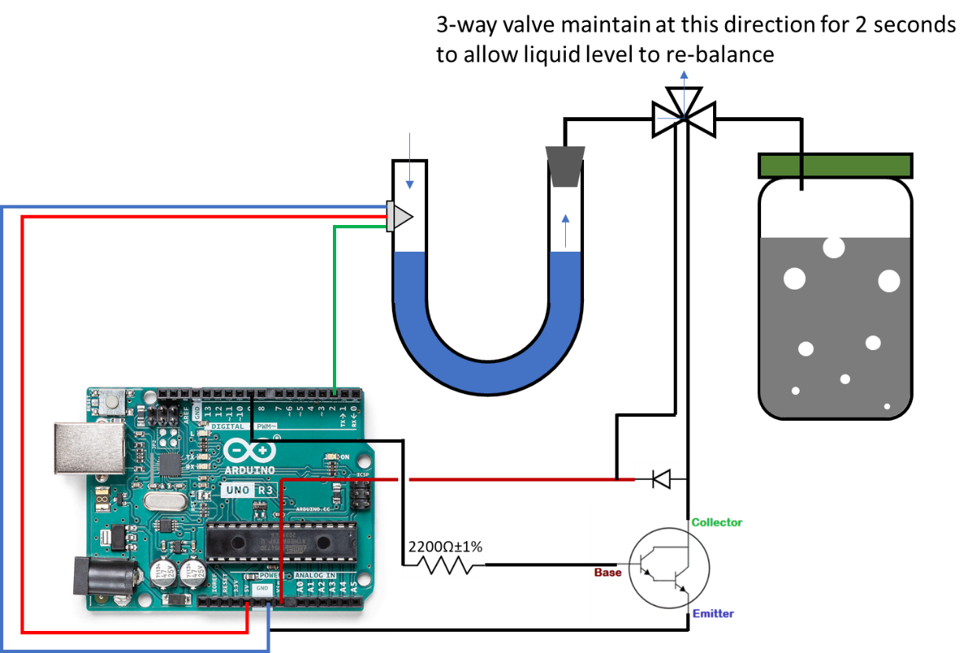
Step 4:
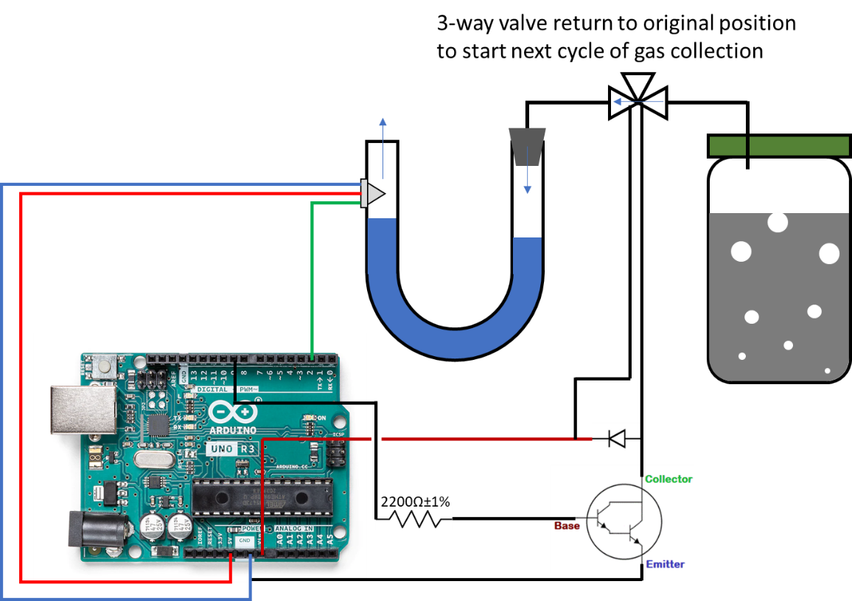

Arduino board draft
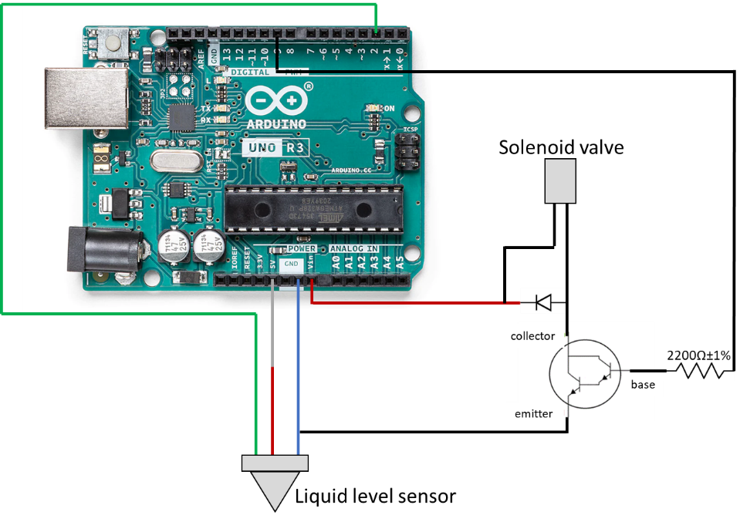

Parts needed (some may be out of stock, need to find equivalents)
Must have:
- One level sensor ($25): Honeywell S&C - LLE101000 Adafruit: https://www.adafruit.com/product/3397
- One Solenoid Valve ($60): Asco 411M1312HV https://www.radwell.com/Buy/ASCO/ASCO/411M1312HV
- One Manifold ($28/pack of 4): clippart #15490-5 http://www.clippard.com/
- [Already in lab] One #10-32 to 1/8” ID Hose Fitting ($6/Pack of 10): #11752-3-PKG http://www.clippard.com/
- One Arduino Uno R3 (Atmega328 - assembled) ($24) #50 https://www.adafruit.com/
- One RGB LCD Shield Kit w/ 16x2 Character Display - Only 2 pins used! - NEGATIVE DISPLAY ($24) #714 https://www.adafruit.com/
- One TIP120 Power Darlington Transistors - 3 pack ($2.5) #976 https://www.adafruit.com/
- One 12 VDC 1000mA regulated switching power adapter - UL listed ($8) #798 https://www.adafruit.com/
- 1N4001 Diode - 10 pack ($1.5) #755 https://www.adafruit.com/
- Adafruit Perma-Proto Quarter-sized Breadboard PCB - Single ($3) #1608 https://www.adafruit.com/
- 2.2K Ohm Flameproof Electronic Metal Film Resistor ($8.67) Amazon: https://www.amazon.com/gp/product/B016D8CAB4/ref=crt_ewc_title_dp_3?ie=UTF8&psc=1&smid=ATVPDKIKX0DER
Good to have but optional
- One Quick-Disconnect Push-In Signal/Power Connector - Male ($26): McMaster #6134T43 https://www.mcmaster.com
- One Quick-Disconnect Push-In Signal/Power Connector - Female ($14): McMaster #6134T33 https://www.mcmaster.com
- Small Plastic Project Enclosure - Weatherproof with Clear Top ($10) #903 https://www.adafruit.com/

Arduino Codes
// LCD library includes
#include <Wire.h>
#include <Adafruit_MCP23017.h>
#include <Adafruit_RGBLCDShield.h>

// Port definition
#define OPTO_PIN 2
#define VALVE_PIN 9

// LCD variable
Adafruit_RGBLCDShield lcd = Adafruit_RGBLCDShield();

// Other variables
int counter = 0;
bool open_valve = false;

void setup() {
// Initialize pin mode
pinMode(OPTO_PIN, INPUT);
pinMode(VALVE_PIN, OUTPUT);
Serial.begin(9600);

// set up the LCD's number of columns and rows:
lcd.begin(16, 2);
lcd.setBacklight(0x7);
lcd.setCursor(0,0);
lcd.print("Bio-Gas Counter");
lcd.setCursor(0,1);
lcd.print(counter);
//Serial.println(counter);
}

void loop() {
lcd.setCursor(0, 1);

// Read buttons status
uint8_t buttons = lcd.readButtons();
if (buttons & BUTTON_SELECT)
{
counter = 0;
lcd.print(counter);
}
if (buttons & BUTTON_LEFT) {
digitalWrite(VALVE_PIN,HIGH);
} else {
digitalWrite(VALVE_PIN,LOW);
}

gas_counter();

if(open_valve)
{
digitalWrite(VALVE_PIN,HIGH);
delay(2000);
digitalWrite(VALVE_PIN,LOW);
open_valve = false;
}
}

void gas_counter()
{
if(!digitalRead(OPTO_PIN))
{
counter++;
lcd.print(counter);
Serial.println(counter);
open_valve = true;
}
}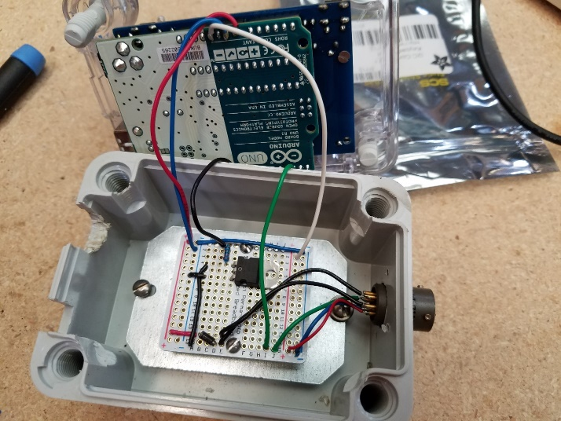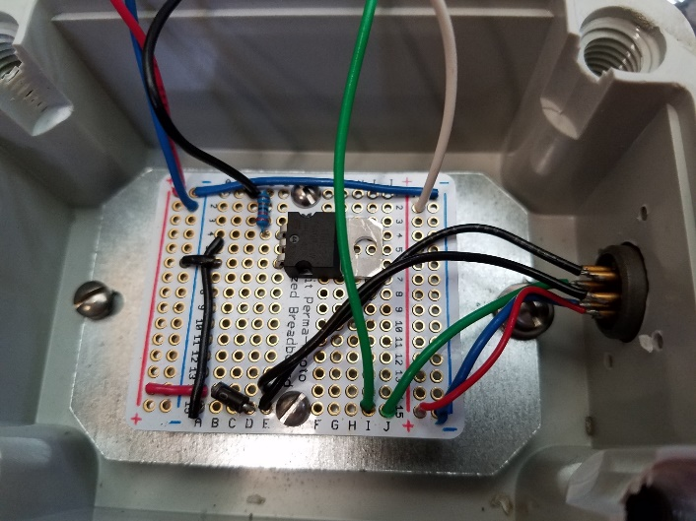
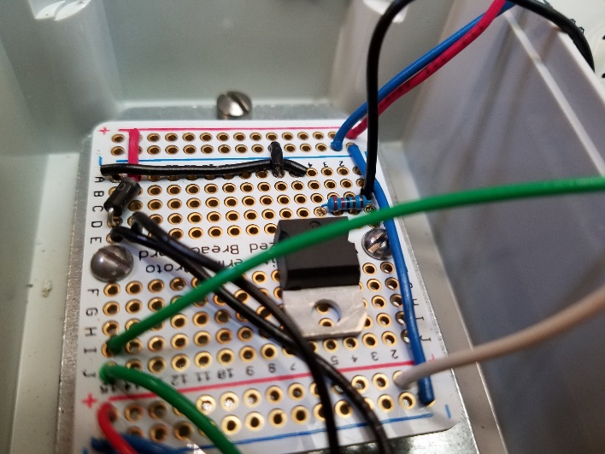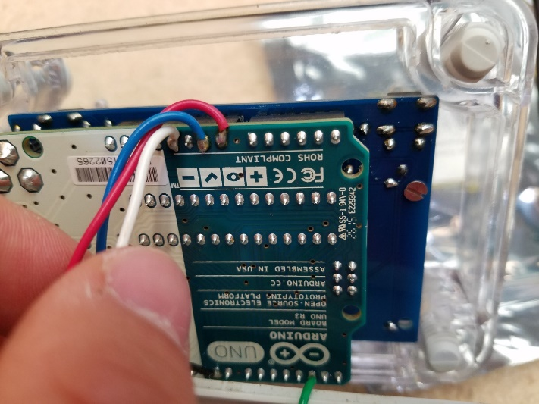

Overall reactor design for a two-phase system (just an idea for an old project, not necessary what we are developing here at WSU)
